Experiment Number-14

Title – Write a program to demonstrate hierarchical inheritance

**Theory**

**What is Inheritance in Python:**Inheritance in python programming is the concept of deriving a new class from an existing class. Using the concept of inheritance we can inherit the properties of the existing class to our new class. The new derived class is called the child class and the existing class is called the parent class.

**Benefits of inheritance are:**

Inheritance allows you to inherit the properties of a class, i.e., base class to another, i.e., derived class. The benefits of Inheritance in [Python](https://www.geeksforgeeks.org/python-programming-language/) are as follows:

* It represents real-world relationships well.
* It provides the **reusability** of a code. We don’t have to write the same code again and again. Also, it allows us to add more features to a class without modifying it.
* It is transitive in nature, which means that if class B inherits from another class A, then all the subclasses of B would automatically inherit from class A.
* Inheritance offers a simple, understandable model structure.
* Less development and maintenance expenses result from an inheritance.

**Types of Inheritance in Python**

Types of Inheritance depend upon the number of child and parent classes involved. There are five types of inheritance in python programming:

**1).** Single inheritance  
**2).** Multiple inheritances  
**3).** Multilevel inheritance  
**4).** Hierarchical inheritance  
**5).** Hybrid inheritance

### ****Single Inheritance:****

Single inheritance enables a derived class to inherit properties from a single parent class, thus enabling code reusability and the addition of new features to existing code.

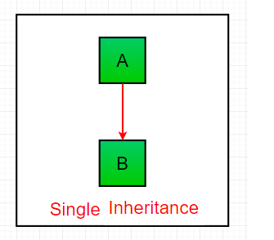

Syntax –

class class1:

    <class-suite>

class class2(class1):

    <class suite>

**Multiple Inheritance**

When child class is derived or inherited from more than one parent class. This is called multiple inheritance. In multiple inheritance, we have two parent classes/base classes and one child class that inherits both parent classes properties.

Python Inheritance

Syntax:

class Base1:

    <class-suite>

class Base2:

    <class-suite>

.

.

.

class BaseN:

    <class-suite>

class Derived(Base1, Base2, ...... BaseN):

    <class-suite>

**Multilevel inheritance**

In multilevel inheritance, we have one parent class and child class that is derived or inherited from that parent class. We have a grand-child class that is derived from the child class. See the below-given flow diagram to understand more clearly.

Python Inheritance

Syntax:

class class1:

<class-suite>

class class2(class1):

<class suite>

class class3(class2):

<class suite>

**Hierarchical inheritance**

When we derive or inherit more than one child class from one(same) parent class. Then this type of inheritance is called hierarchical inheritance.

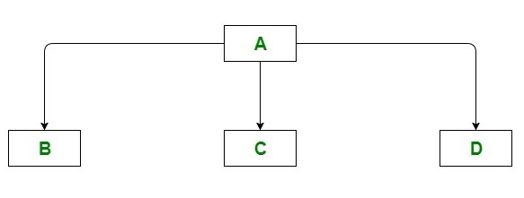

Syntax

class A:

<class-suite>

class B(A):

<class suite>

class C(A):

<class suite>

class D(A):

<class suite>

**Hybrid inheritance**

Hybrid inheritance satisfies more than one form of inheritance ie. It may be consists of all types of inheritance that we have done above. It is not wrong if we say **Hybrid Inheritance** is the combinations of simple, multiple, multilevel and hierarchical inheritance. This type of inheritance is very helpful if we want to use concepts of inheritance without any limitations according to our requirements.

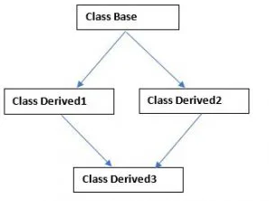

Syntax

class classbase:

<class-suite>

class derived1(classbase):

<class suite>

class derived2(classbase):

<class suite>

class derived3(derived1, derived2):

<class suite>

Exercise –

1. Write a program to demonstrate simple inheritance
2. Write a program to demonstrate multiple inheritance
3. Write a program to demonstrate multilevel inheritance
4. Write a program to demonstrate hierarchical inheritance
5. Write a program to demonstrate hybrid inheritance